Solubility Curve of Potassium Nitrate in Water

Introduction

Background (Read through this before prelab)

Solutions are homogeneous mixtures of solvents (the larger volume of the mixture) and solutes (the smaller volume of the mixture). For example, a hot chocolate is a solution, in which the solute (the chocolate powder) is dissolved in the solvent (the milk or water). The solute and solvent can be either a solid, liquid or a gas. A solution forms when the attractive forces between the solute and the solvent are similar. For example, the ionic or polar solute, NaCl, dissolves in water, a polar solvent. The phase “like dissolves like” has often been used to explain this.
As the water molecules collide with the ionic compound (NaCl), the charged ends of the water molecule become attracted to the positive sodium ions and negative chloride ions. The water molecules surround the ions and the ions move into solution. This process of attraction between the water molecules (the solvent) and the ionic compound (NaCl, the solute) is called solvation. Solvation continues until the entire crystal has dissolved and all ions are distributed throughout the solvent.
Solvation Process of NaCl
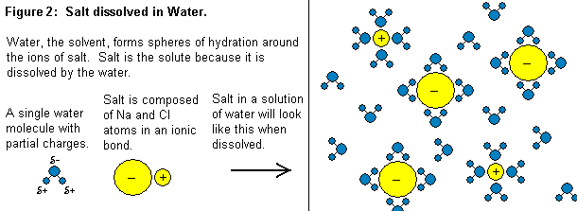
http://homepages.ius.edu/GKIRCHNE/Water.htm

Some solutions form quickly and others form slowly. The rate depends upon several factors, such as, the size of solute, stirring, or heating. When making hot chocolate, we stir chocolate powder into hot milk or water. When a solution holds a maximum amount of solute at a certain temperature, it is said to be saturated. If we add too much chocolate powder to the hot milk, the excess solute will settle on the bottom of the container. Generally, the chocolate powder dissolves better in hot milk than cold milk. Thus, heating the solution can increase the amount of solute that dissolves. Most solids are more soluble in water (solvents) at higher temperatures.
Solubility is the quantity of solute that dissolves in a given amount of solvent. The solubility of a solute depends on the nature of the solute and solvent, the amount of solute, the temperature and pressure (for a gas) of the solvent. Solubility is expressed as the quantity of solute per 100 g of solvent at a specific temperature.

Objectives (Write your purpose from this)

In this experiment, you will be:
- measuring the solubility of different quantities of KNO₃ at various temperatures of crystallization. The start of crystallization indicates that the solution has become saturated at this temperature.
- constructing a solubility curve for KNO₃ in water.
- able to identify and understand the key terms: solubility, solute, solvent, solvation, saturated, unsaturated and supersaturated solutions.
- able to use the solubility curve graph to solve various problems and determine trends in the curve.

Procedures

- Divide the lab up so that one lab partner completes steps 2-3, while the other partner begins on step 4.
- Using a marking pencil, number four test tubes and place them into a test tube rack.
- Using a balance to measure the KNO_{3,} prepare the test tubes as indicated below:

Test tube # grams of KNO₃ ml of distilled H₂O
1 2.0 5
  - 4.0 5
  - 6.0 5
  - 8.0 5

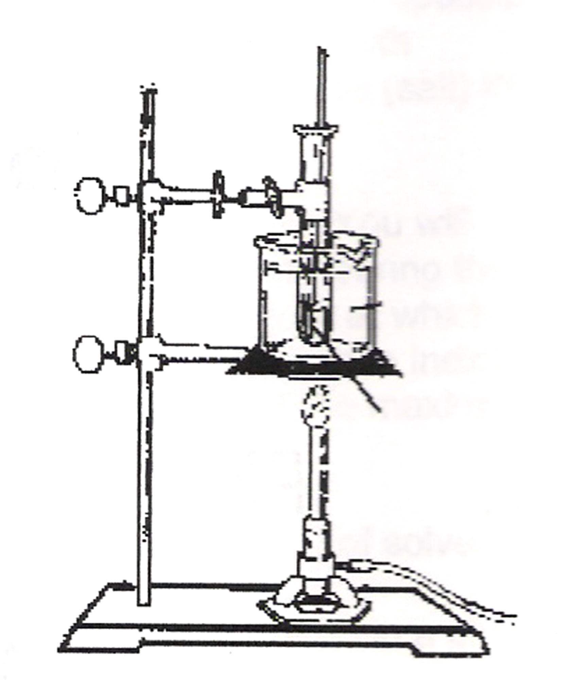
- Fill a 400 ml beaker about ¾ full of tap water. This will be used as a hot water bath. Place the water bath and test tube #1 on the stand (already set up), firmly attached. Heat the water to 90 ºC and adjust the flame to maintain this temperature.
- Stir the KNO₃-water mixture with a glass stirring rod until the KNO₃ is completely dissolved. Loosen the clamp and, using a test tube holder, remove the tube.
- One lab partner repeats step 5 for test tube #2. The other lab partner holds a warm thermometer into the solution in the test tube # 1. Hold the test tube up to the light and water for the first signs of crystallization in the solution. Record the temperature immediately as crystallization begins in the data table.
- Repeat steps 5 and 6 for all four test tubes. One partner should do step 5 and the other step 6. Record all temperatures in the data table.

Data Table

Test tube # | grams of KNO₃ + ml of H₂O | Crystallization temp. (ºC)
1 | 2g/5ml
2 | 4g/5ml
3 | 6g/5ml
4 | 8g/5ml

Calculations

- Convert mass/5.0 ml ratios to mass/100 ml ratios.

- Combine data with another data (for more data points). Plot your combined data. Note: Plot the mass of solute per 100 ml of water on the y-axis and the temperature of crystallization on the x-axis.

- Construct a solubility curve by drawing a best fit curve on your graph. (Note: You are able to “throw out” data points that seem skewed from the norm.)

Post Lab Questions

- According to your graph, how does the solubility of KNO₃ change as the temperature rises?

- Explain at the molecular level why this relationship exists between temperature and solubility.

- Using your graph, how many grams of KNO₃ can be dissolved in 100 ml of water at the following temperatures?

  - 40 ºC
  - 50 ºC

- On your solubility curve, what is the change in solubility from 30ºC to 60ºC?

- Using your graph, how much KNO₃ must be added to make a saturated solution at 55 ºC.

Conclusion

